Data Flow Diagram & User Stories

Parameter | Details
Date | 18 June 2026
Team ID
Project Name | Book A Doctor
Maximum Marks | 4 Marks

____________________________________________________

Data Flow Diagrams:
A Data Flow Diagram (DFD) is a traditional visual representation of the information flows within a system. A neat and clear DFD can depict the right amount of the system requirement graphically. It shows how data enters and leaves the system, what changes the information, and where data is stored.

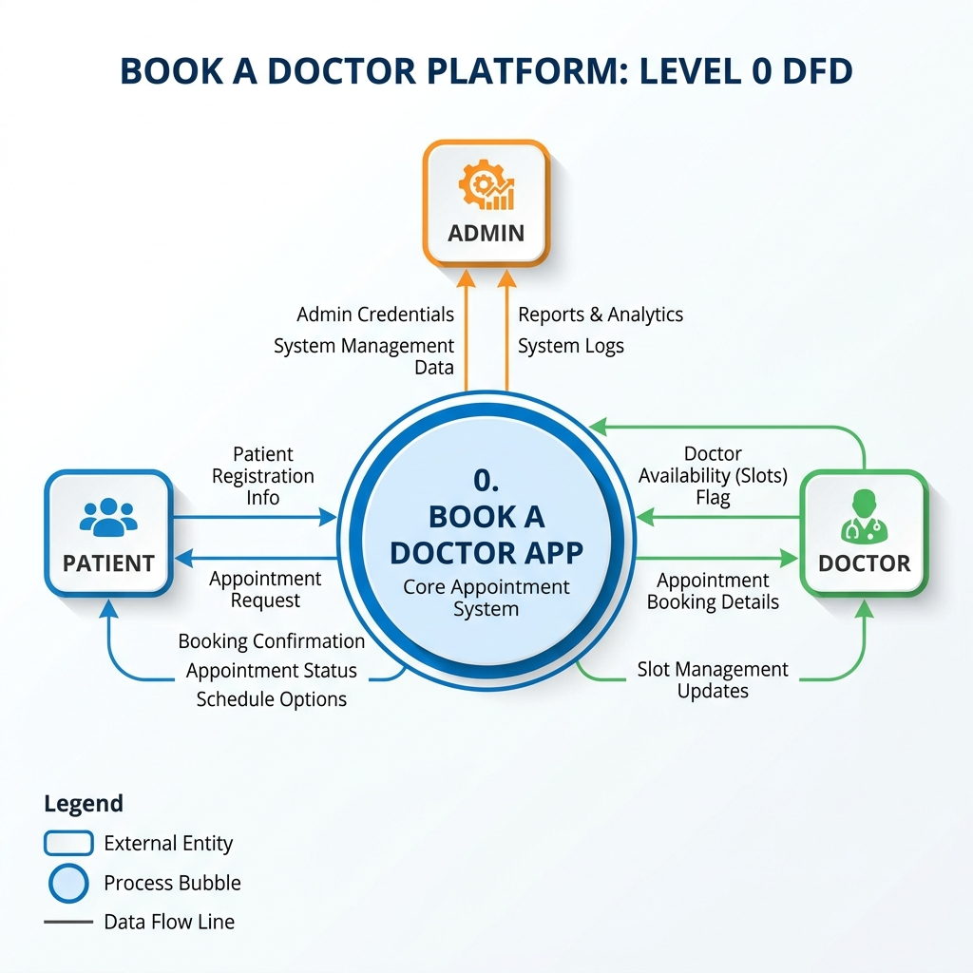
Data Flow Diagram Level 0

DFD Level 0 Description
At Level 0 (Context Diagram), the Book A Doctor platform is represented as a single central process. Three external entities interact with it:
- Patient: Submits registration info, logs in, filters doctors, submits booking requests, and uploads records. Receives scheduling notifications.
- Doctor: Manages calendar slots, updates appointment decisions (Approved/Rejected), and reviews records. Receives patient details.
- Admin: Views metrics counts, approves pending doctor applications, and deletes user accounts.

DFD Level 1 Description
- Process 1.0 (Auth): Manages registrations, credentials encryption, and JWT token signatures.
- Process 2.0 (Doctor Slots): Handles updates to slots and availability.
- Process 3.0 (Booking Engine): Registers appointment transactions, slot reservations, and triggers notification logs.
- Process 4.0 (Document Storage): Receives file streams and writes to uploads folder, saving document mappings to DB.
- Process 5.0 (Admin Panel): Aggregates collection counts and handles doctor approval flags.
- Data Stores: Users Collection, Doctors Collection, Appointments Collection, Documents Collection.

____________________________________________________

User Stories:
Use the below template to list all the user stories for the product.

